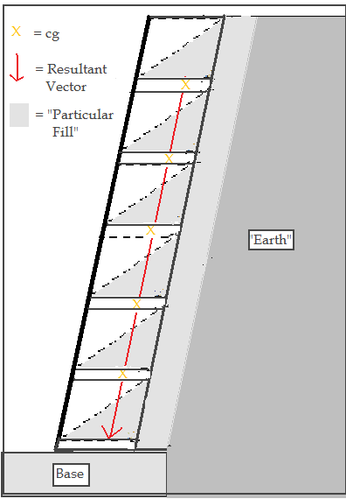

“Particular Wall”
Staggered to parallel Resultant Vector of Rankine Horizontal and “Particular Fill” Center of Gravity Vertical Force
(Rh / Rv)

